**Result:**

**Hand Gesture Recognition Output**

1. **Okay**

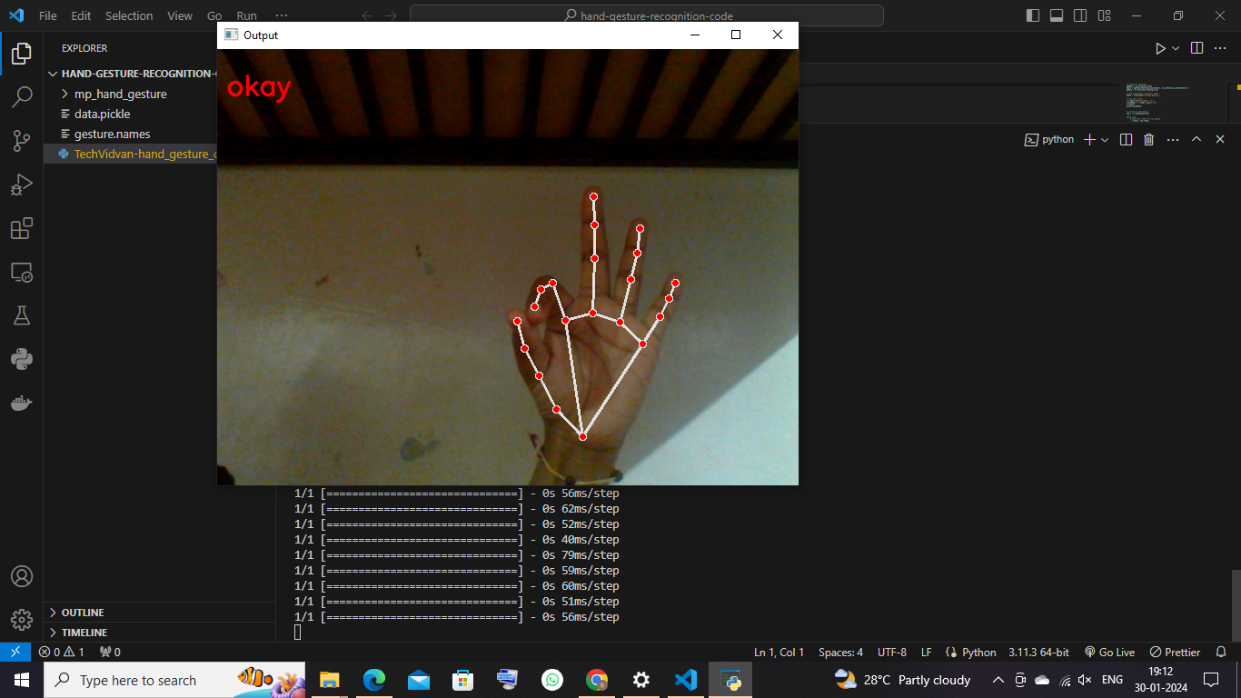

1. **Thumbs up**

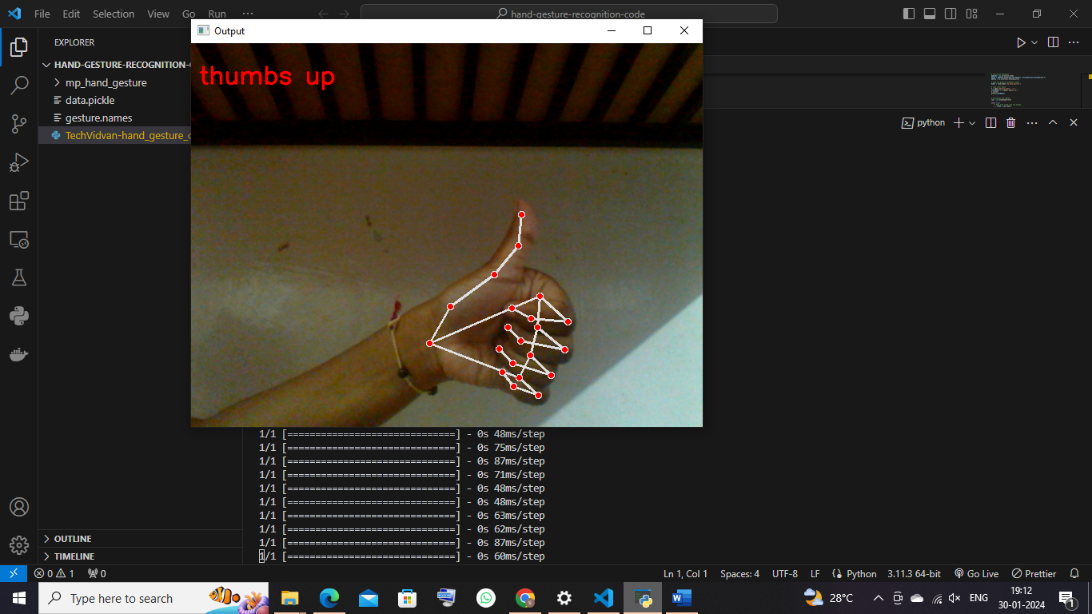

1. **Thumbs down**

